Juan Rojas

Advance Robotics Project Report

Things to include:

- Title page
- Contents
- Intro
- Objectives
- Scenario/Technical approach
- Tasks and Shedule Diagram
- Hardware and Software (found below – need to add Segway info)
- Experiments
- Current Status and Future Plans
- Conclusions
- References
- Appendices (my part is included here)

hardware And Software

The hardware consists of three basic systems: the right arm, a pan-tilt vision system, and the right hand (the left arm and hand were not used in this demo). Figure 1 shows these systems and their component pieces.
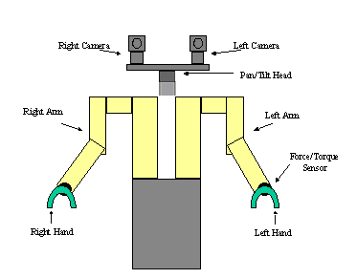
Figure 1 - ISAC Test Bed

Each piece of hardware is connected to a computer for control purposes:

- Popeye – controls the right arm and the right hand.
- Armstrong – controls the Pan-Tilt camera motors and the camera frame grabbers.

Arm

The arm is a six DOF serial robot manipulator. Its actuators are pneumatic muscles called Rubbertuators.

The Rubbertuator is a pneumatic artificial muscle. Pairs of Rubbertuators work in opposition to move a joint, just as animal muscles do. Rubbertuator joints have some disadvantages; for example, hysteresis and non-linearity. They are, however, lightweight and consume less power than DC motors [1].

A common scheme for position-based control of a Rubbertuator joint is to inflate each Rubbertuator to a bias value. The joint input is then the pressure difference, ΔP, between the two Rubbertuators. A servo loop then commands ΔP, using angle feedback. Most control laws for Rubbertuator joints are position based; that is, the controller tries to achieve some desired joint angle. Several schemes, including PID and neuro-fuzzy, have been used to control position [2].

The airflow for the arm is shown in Figure 2.1. The compressor in room 125 provides compressed air. This travels by a hose through the ceiling to the storage tank. Air from the storage tank passes through the air dryer to the valve arrays for the left arm, right arm, and the pneuhand. It is important to pass the air through the dryer because impurities, such as oil, can be harmful to the Rubbertuators and the servo valves.
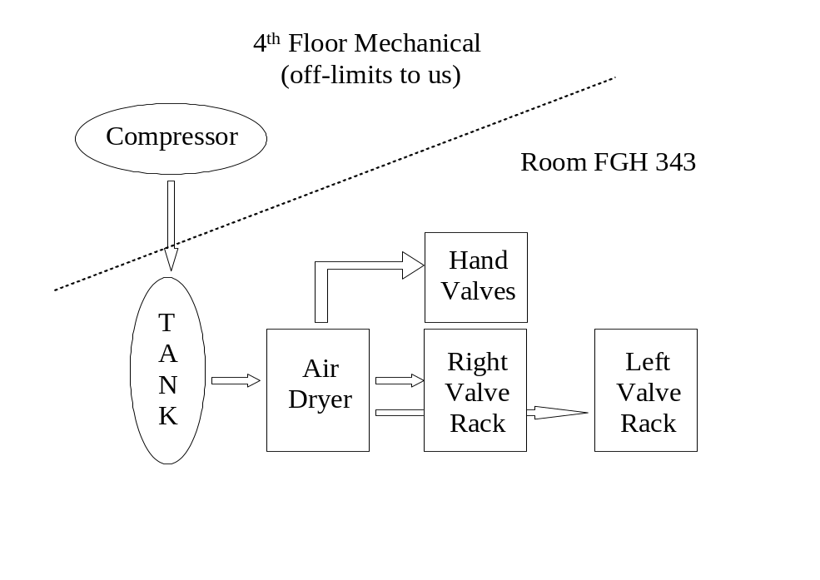
Figure 2.2 - Airflow

Theory
The angles measured by the encoders are converted to physical angles by the following formula:

PhysicalAngles = (RawEncoder- EncoderOffset)/ EncoderGain

However, most agents in the system deal with the robot’s logical angles. These sets of angles are different, because of the geometry of the robot. The first two angles, the base and shoulder, are the same for both sets. However, the other logical angles are functions of some two physical angles. The equations for mapping between the two sets are given by: (note: the numbering 1-6 is referred to as 0-5 in the C++ code)

L1 = p1;
L2 = p2;
L3 = 0.5(p3 + p4)
L4 = p3 - p4
L5 = 0.5(p5 + p6)
L6 = p5 - p6

These equations can be solved for the physical angles, giving:

p3 = L3 + 0.5 * L4
p4 = L3 - 0.5 * L4
p5 = L5 + 0.5 * L6
p6 = L5 - 0.5 * L6

Kinematics is a mapping between a robot’s joint space and its Cartesian space. The forward kinematics equations describe the position and orientation of the one of the robot’s frames--usually the end-effector or tool frame--as a function of the arm joint angles. The inverse kinematics calculates the joint angles necessary to give a frame a certain position and orientation.

Control Loop
Figure 3 shows data flow through the agent’s control loop. Position commands to the arm come from the DesiredLogicalAngles vector signal. These commands are filtered by the Filter mechanism, which uses a first-order IIR low-pass digital filter. The FilteredDesiredLogicalAngles are converted by the Sampler mechanism into DesiredPhysicalAngles. These are sent to the Controller mechanism, which uses them and the current PhysicalAngles (also produced by the Sampler mechanism) to compute the Pressure output. The Pressure is sent to the Sampler, which drives the servo valves that control the pressure in the Rubbertuators.

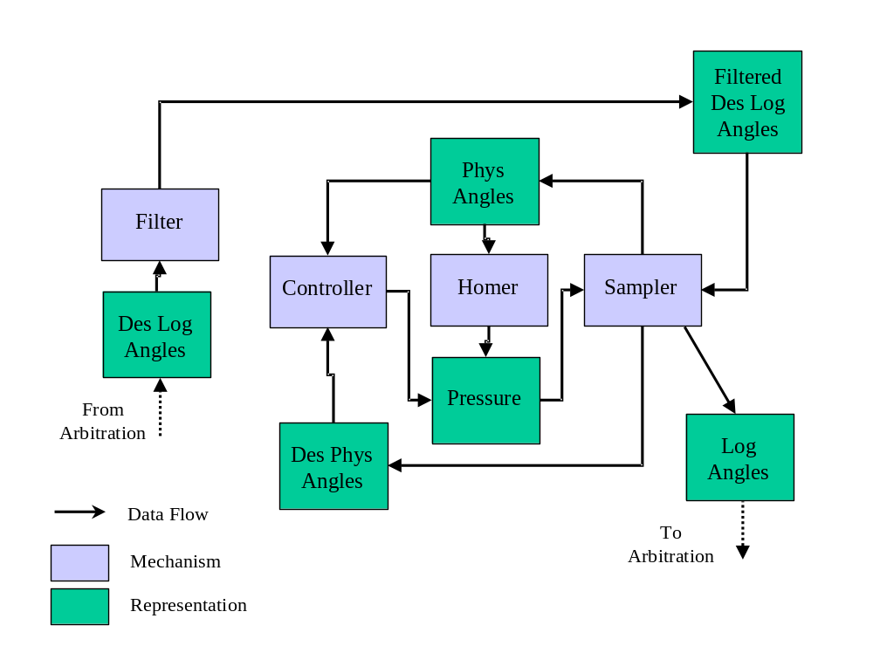
Figure 2.3 - SoftArm Agent Control Loop

The Sampler mechanism’s role is complex. It reads the encoder values from the hardware, converts them to Physical and Logical angles. It then converts the FilteredDesiredLogicalAngles to DesiredPhysicalAngles. Finally, it sends the Pressure commands to the servo valves.

Arbitration Loop
Figure 2.4 shows the arbitration of commands from other agents. The SoftArm can be commanded in either Cartesian or angle space. Cartesian commands are sent to the CartArb relationship. This relationship component produces a DesiredXYZ position for the SoftArm. This position is converted to angles by the InverseKinematics mechanism. The angles computed are placed in the Command vector of the KinLink motion link, which connects to the AngleArb relationship. This input along with other inputs from other agents (which want to command the arm in angle space), are used by the CmdArb relationship to compute the DesiredLogical angles (which are sent to the control loop).

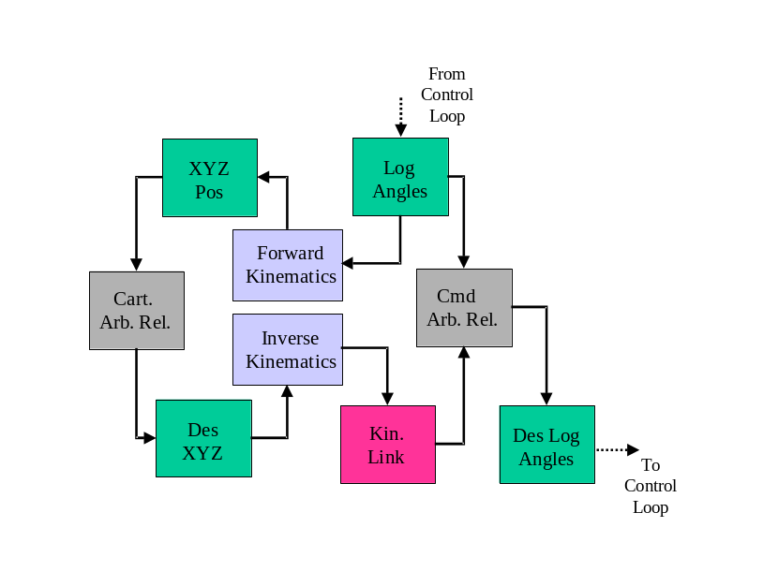
Figure 2.4: SoftArm Agent Arbitration Loop

The current Logical angles from the control loop are reported to client agents by the CmdArb relationship. The Logical angles are also converted to the SoftArm’s current XYZ position by the ForwardKinematics mechanism. This current XYZ position is reported to client agents by the CartArb relationship.

Agents that command the arm should include a Motion Link that connects to the proper relationship in the arm (e.g., CartArb for Cartesian commands). The arbitration vector should be 7 elements; the first 6 are weights for the respective command vector elements. The 7th is a number indicating whether the command is a velocity command (value=1) or an absolute position command (value = 2).

Agent State Machine In IMA 1.0

The SoftArm agent is controlled by a state machine that contains 4 states.

State 0 is the “homing” state. In this state, the arm is moved through its entire joint range to find the encoder zero locations. The pressure values for the motion sequence are computed by the Homer mechanism. Each time the mechanism is invoked, it outputs the next pressure in the sequence. When the Homer mechanism has completed its sequence, dispatches the agent event (-2,-2). This causes the state machine to transition to State 1.

State 1 sends the arm to its initial “L” position. When it arrives, the Sampler dispatches the event (2,2), sending the state machine to State 2.

State 2 is a transient state in which the vectors in the arbitration loop are initialized. This state automatically transitions to State 3 upon timeout.

State 3 is the normal running state. In this state, the control and arbitration loops operate as described above

References

A. Alford, M. Cambron, A. Srikaew, “ISAC Operation Manual,” CIS Technical Report 99-2.
D. G. Caldwell, G. A. Medrano-Cerda, and M. Goodwin, “Control of Pneumatic Muscle Actuators,” IEEE Control Systems, Feb. 1995.
T. Pack, M. Iskarous, and K. Kawamura, “Comparison of Fuzzy and Nonlinear Control Techniques for a Flexible Rubbertuator-Based Robot Joint,” Proceedings of the Third International Fuzzy Systems and Intelligent Control Conference, 1994.

